Review of Domotex:
Successful Start of the Villeroy & Boch Flooring Line

The first Villeroy & Boch Flooring Line made of high-quality laminate celebrated its world premiere at Domotex from the 11th to the 14th of January. It was the public’s first chance to get a look at its four collections: Country, Contemporary, Heritage and Cosmopolitan, which comprise a total of 22 new decors. As Villeroy & Boch’s license partner, the Swiss Krono Group is producing the Flooring Line at its plants in Germany, Switzerland, Russia and Poland.

Good Results After Successful Kickoff Event

“The response has been exceptionally positive,” says Max von Tippelkirch, CMO of the Swiss Krono Group. “I’m confident that the Flooring Line will become well-established in the market. The fact that Villeroy & Boch is so well-known around the world will be a major driver.”

“We are very happy with how well the collections have been received,” says Michael Magenreuter, Head of Business Development at Villeroy & Boch. “Our idea of enhancing Villeroy & Boch’s living world concept with a line of premium laminate flooring is being enthusiastically applauded.” The prospects are also good that the Swiss Krono Group will be offering parquet floors of the Villeroy & Boch brand

To bridge the gap to Villery & Boch’s well-known “tableware” theme, the stand concept included display cooking. Three times a day, Martin Wrathal prepared tasty treats for our visitors while everyone watched. Visitors to the stand were delighted by his creative compositions, which included gnocchi with boletus mushrooms, scampi in tempura and tender venison sirloin steaks.
The evening before the first day of the fair, about 240 invited guests from different countries converged on the Garden Room of the New City Hall in Hanover. Selected decors of the Villeroy & Boch Flooring Line were displayed in specially assembled living worlds.
A flying buffet, lounge music and indoor fireworks ensured a relaxed mood throughout the evening. Multiple performances by two virtuoso musicians of the Munich AllStars – Natalie Marchenko on sax and Mary Ann on violin – thrilled the guests. They played an uplifting mixture of classical, pop, dance and soul hits ranging from Vivaldi to David Guetta.

For more information on the Villeroy & Boch Flooring Line:
www.floors.villeroy-boch.com

Images
The following images are available in print-ready resolution for downloading from https://www.dropbox.com/sh/m2pjnnfhl6gg6tg/qNcF7Mr1we and may be used in publications free of charge:

The event photographs should be credited to: Björn Hickmann
The trade fair photographs and the picture of the Flooring Line should be credited to: Villeroy & Boch

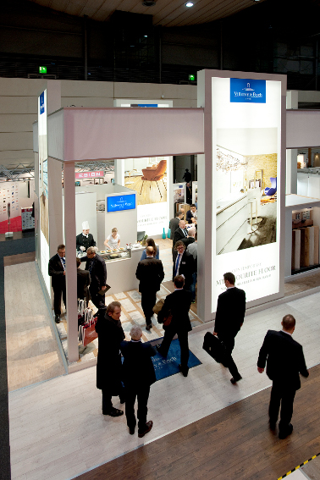
Bustling activity at the Villeroy & Boch Flooring Line exhibit

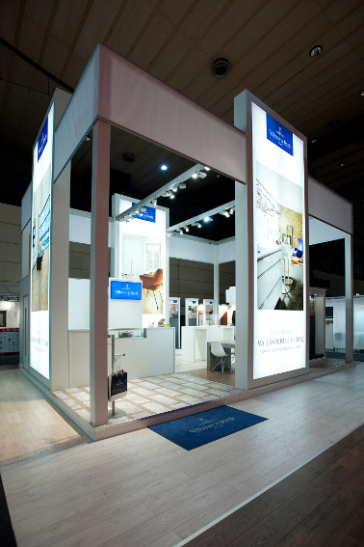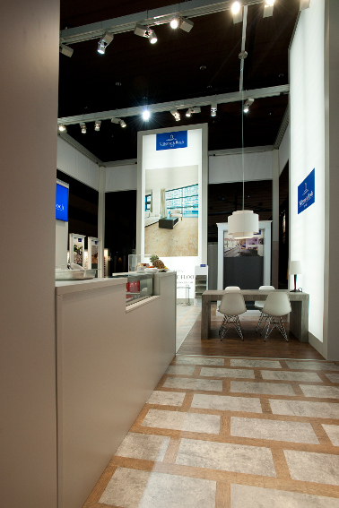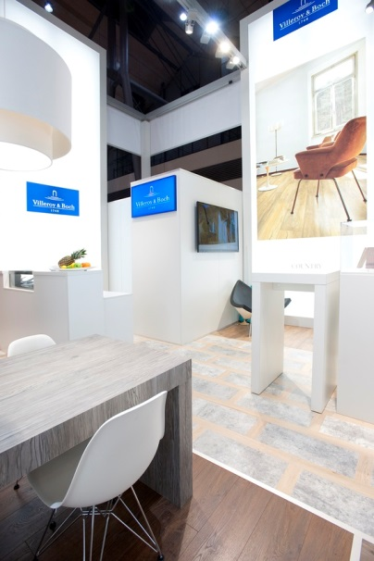
The Villeroy & Boch Flooring Line exhibit at Domotex 2014

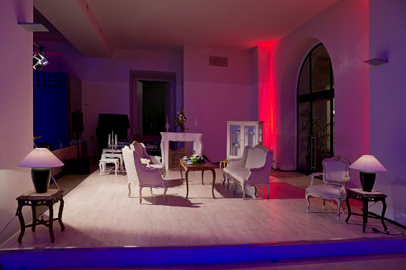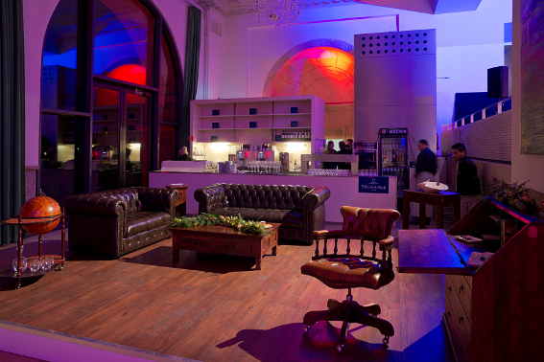

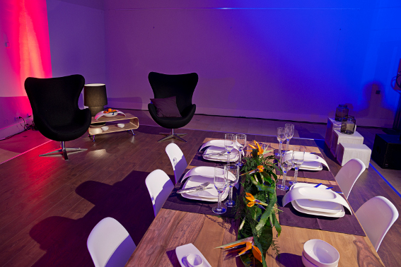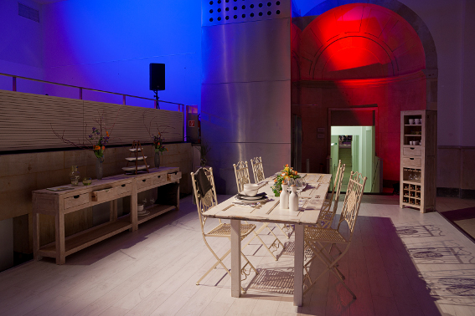
The four living worlds in which the Villeroy & Boch Flooring Line was presented

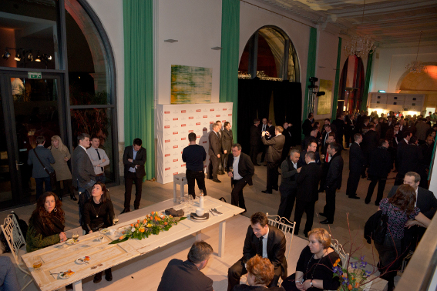
Invited guests at the kick-off event for the Villeroy & Boch Flooring Line in the Garden Room of the New City Hall in Hanover

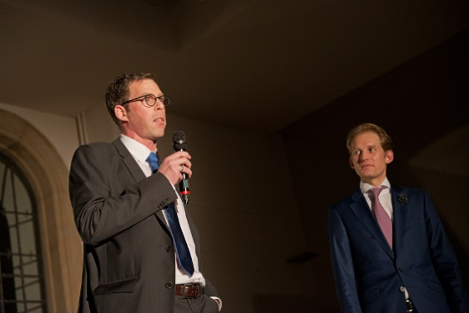
Michael Magenreuter (Head of Business Development at Villeroy & Boch, left) and Max von Tippelskirch (CMO of the SWISS KRONO GROUP, right)
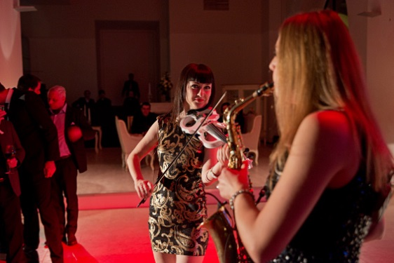
Mary Ann (violin) and Natalie Marchenko (sax) delighted guests at the evening event.
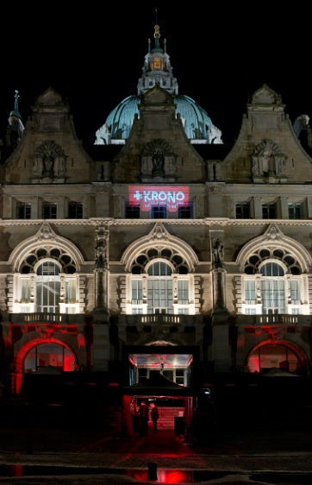
The kick-off event for the Villeroy & Boch Flooring Line took place in the Garden Room of the New City Hall in Hanover.

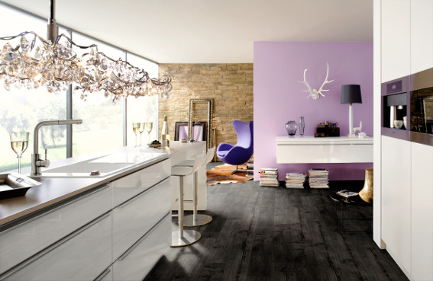
Cover theme of the Villeroy & Boch Flooring Line (VB 801 Teak)

Press Contact:
Ute Bachmann
Tel.: +49 (0)176 99938586
E-mail: u.bachmann@werbeagentur-nowack.de

Villeroy & Boch
Villeroy & Boch is based in Mettlach, Germany and has production facilities in Europe, Mexico and Thailand. It is represented in 125 countries with its product categories bath & wellness, tableware and tiles. A listed joint-stock company, Villeroy & Boch has a history going back more than 265 years.

SWISS KRONO GROUP
The SWISS KRONO GROUP grew out of a firm which was established in Menznau, Switzerland in 1966. Today it is one of the world’s leading producers of engineered wood products with more than 4,500 employees. Its owners and staff are acutely aware of their multiple responsibilities – namely to succeed in business, deliver top quality and reduce environmental burdens – and are committed long-term to efficiently producing modern, eco-friendly products made from wood, a renewable raw material. KRONO Holding AG, which spearheads the Group, has its head office in Lucerne, Switzerland. www.krono.com

