“Growing Together”
SWISS KRONO GROUP at DOMOTEX 2014

At the upcoming Domotex trade fair in Hanover on 11-14 January 2014, the SWISS KRONO GROUP will impressively demonstrate the incredible variability of laminate flooring available today by showcasing the results of its constant efforts to develop new, fascinating decors. A leading-edge stand (C23 in Hall 9) with 550 square metres of exhibition space will be shared by KRONOTEX from Heiligengrabe in Germany, KRONOSWISS from Menznau in Switzerland, KRONOPOL from Poland and KRONOSTAR from Russia. “Our motto for Domotex is ‘Growing Together’,” says Maciej Karnicki, CEO of the SWISS KRONO GROUP. “As a family-run enterprise that has blossomed into a global player, we are looking forward to seeing how trade visitors from around the world respond to our product highlights for the coming season.”

KRONOTEX: Oak and Mountain Spruce, Metallic Effects and Tile Looks
KRONOTEX based in Heiligengrabe, Germany has just added the first Mountain Spruce décor to its Mammut collection. It features an impressively nature-identical structure.
Oak remains one of the most popular looks for flooring. And KRONOTEX keeps showing that the potential variations on this theme are still far from exhausted. Several of its collections therefore include Harbour Oak decors. Exceptionally attractive colours and authentically nature-identical structures make them a compelling visual and tactile experience.
Four unique unicolour decors – in Petrol, Gold, Silver and Titanium with metallic effects – have augmented the Glamour collection. Their shimmering appearance is achieved by the addition of mother-of-pearl pigments.
The Mega collection has also been enriched by four new decors which respond to the current popularity of tile looks. The panels look like real ceramic tiles with a wood design.
These collections will run for two years starting this season.

KRONOSWISS: Swiss Floor 2014 and Grand Selection with App
At the Swiss firm, the focus is on the Grand Selection flooring line with eight oak and five walnut decors. KRONOSWISS also supplies an app which makes it easy for merchants, planners, tradesmen and consumers to get information and make selections. The app lets the user quickly photograph a room and digitally install a Grand Selection floor in the image to preview how the floor would look in an actual setting.
Another highlight is the new Swiss Floor 2014 floor collection with 120 versatile decors including the classics Swiss-Noblesse and Swiss-SyncChrome. The collection has been extended by a new 10mm range: the elegant, trendy Swiss-LifeStyle decors, which break new ground by incorporating the new nature-identical CF structure, a finely porous oak structure which sets new standards.

KRONOPOL: Collection for the Senses and Innovative 3D Decors
The Polish company will showcase new versions of its Kronopol Laminate Flooring and Kronopol Platinum Flooring collections. For the first time, a complete Aurum collection will be on display at a trade fair. Its five subdivisions – Sound, Aroma, Vision, Sensual and Taste – target our senses and evoke a very special ambience with their exclusive designs and extraordinary 3D surface structures.

KRONOSTAR: Synchro-Tec and SymBio
Eagerly awaited by customers in Russia and elsewhere: Synchro-Tec, KRONOSTAR’s first own collection featuring Synchronpore (an in-register embossing technology). The appearance and texture of its six oak decors with country cottage character are virtually indistinguishable from those of real wood.
SymBio is another new collection from KRONOSTAR. It comprises six luxurious oak decors whose stylish colour gradients and sophisticated surface embossing (matrix) perfectly emulate real wood, merging to create a true-to-nature effect that simultaneously embodies a symbiosis of nature and technology.

The Fair Stand of the SWISS KRONO GROUP
In Halls 8 and 9, everything will be about hardwood, parquetry and laminate floors. “Inspired by Nature” is the title of the exhibition area containing the SWISS KRONO GROUP’s eye-catching KRONO-red stand. With the motto “Growing Together”, the corporate group will make a strong, homogeneous impression despite the enormous distances separating its sites, which are scattered across seven countries on three continents. “In Russia or Poland, Germany or Switzerland, France or the United States, what unites us is our enthusiasm for designing and producing a steady stream of new, attractive laminate floors,” explains Maciej Karnicki. “Their astonishing decors and innovative surfaces respond to the ever-changing trends in interior decorating. We help to enable personalised rooms with the ambiences that people want and in which they feel good.”

Visit us at Domotex, 11-14 January 2014: Hall 9/Stand C23

Pictures:
The following pictures are available in a print-ready resolution and may be reproduced in periodicals free of charge provided that they are credited to SWISS KRONO GROUP. https://www.dropbox.com/sh/71zpt2pfp9x7428/UbSi3L1WHE

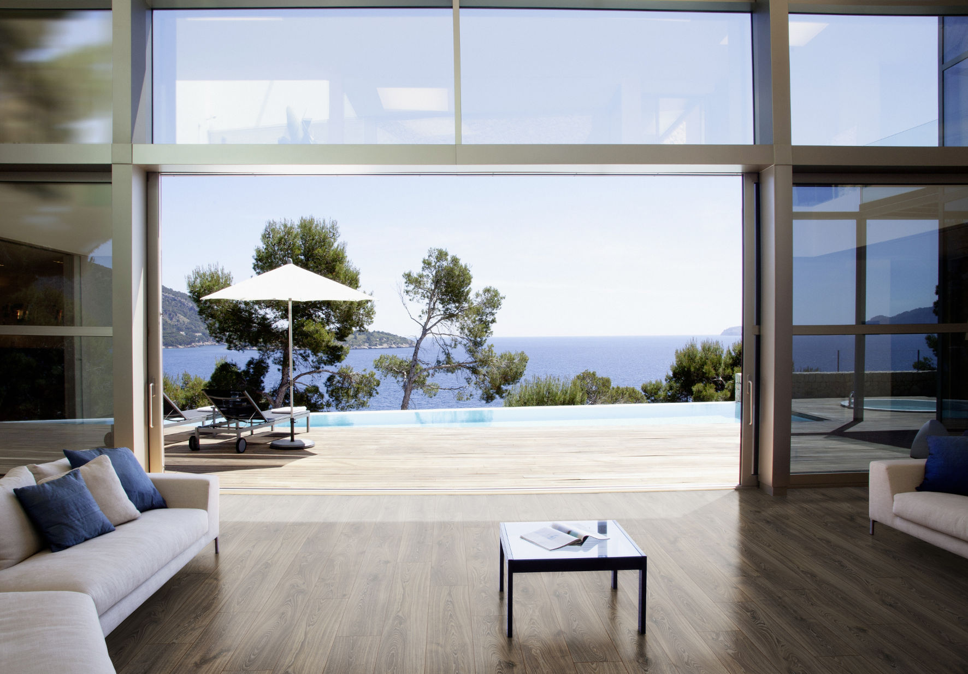 KRONOTEX Robusto Rip Oak (D 3075)

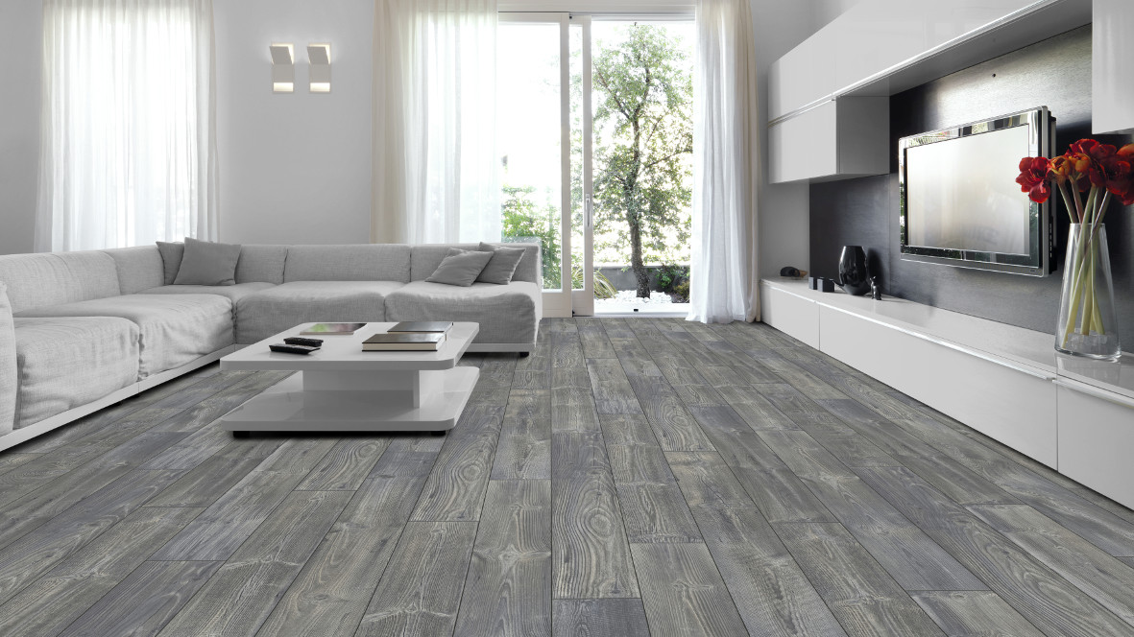 KRONOTEX Mammut Mountain Spruce (D 3577)

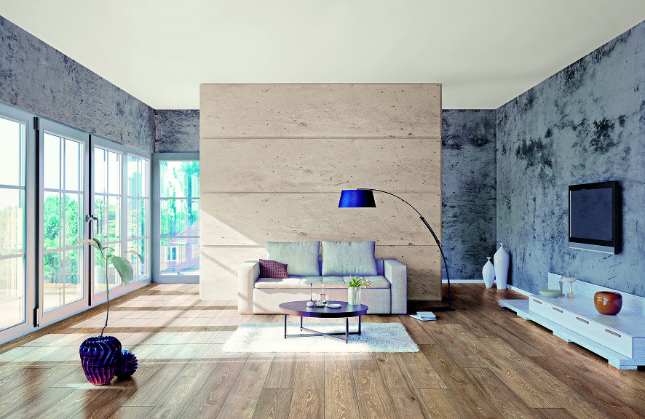 KRONOSWISS Grand Selection Oak Camel (CR 4194)

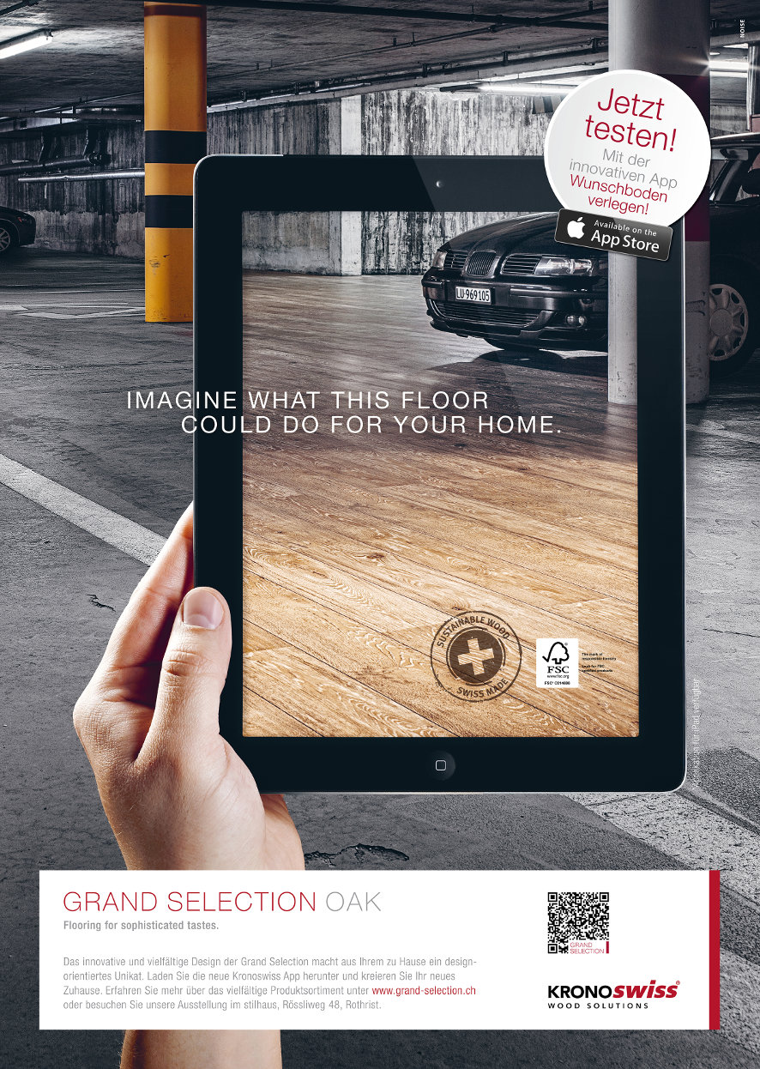 KRONOSWISS Grand Selection App

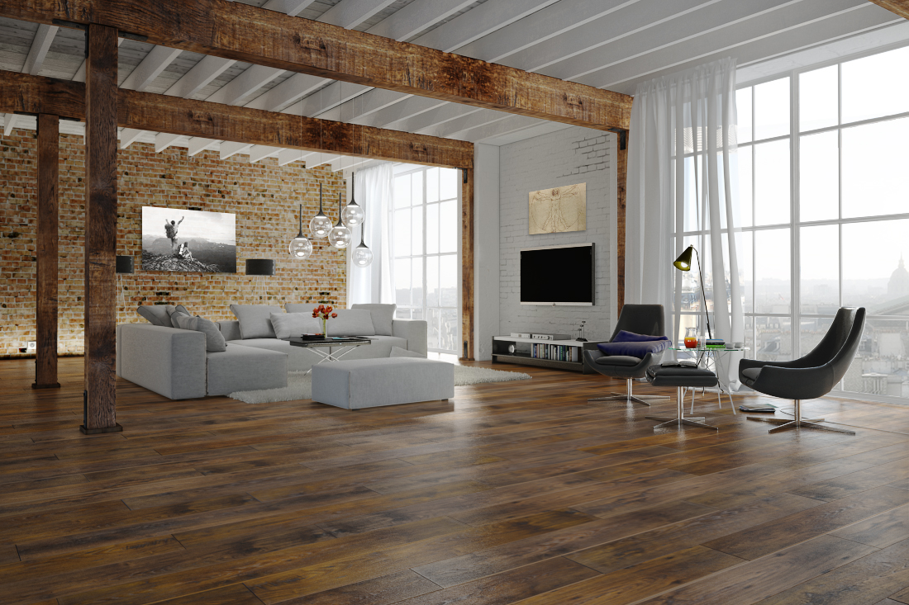 KRONOPOL Aurum Vision: Leonardo Oak (D 3347)

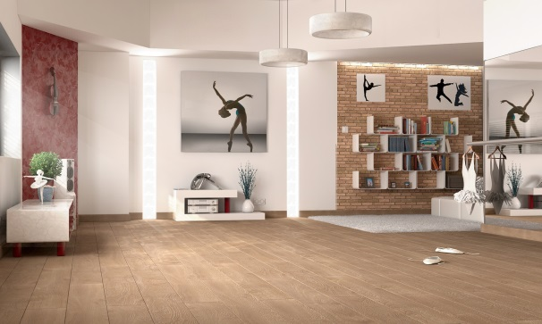 KRONOPOL Aurum Sensual: Salsa Oak (D 2026)

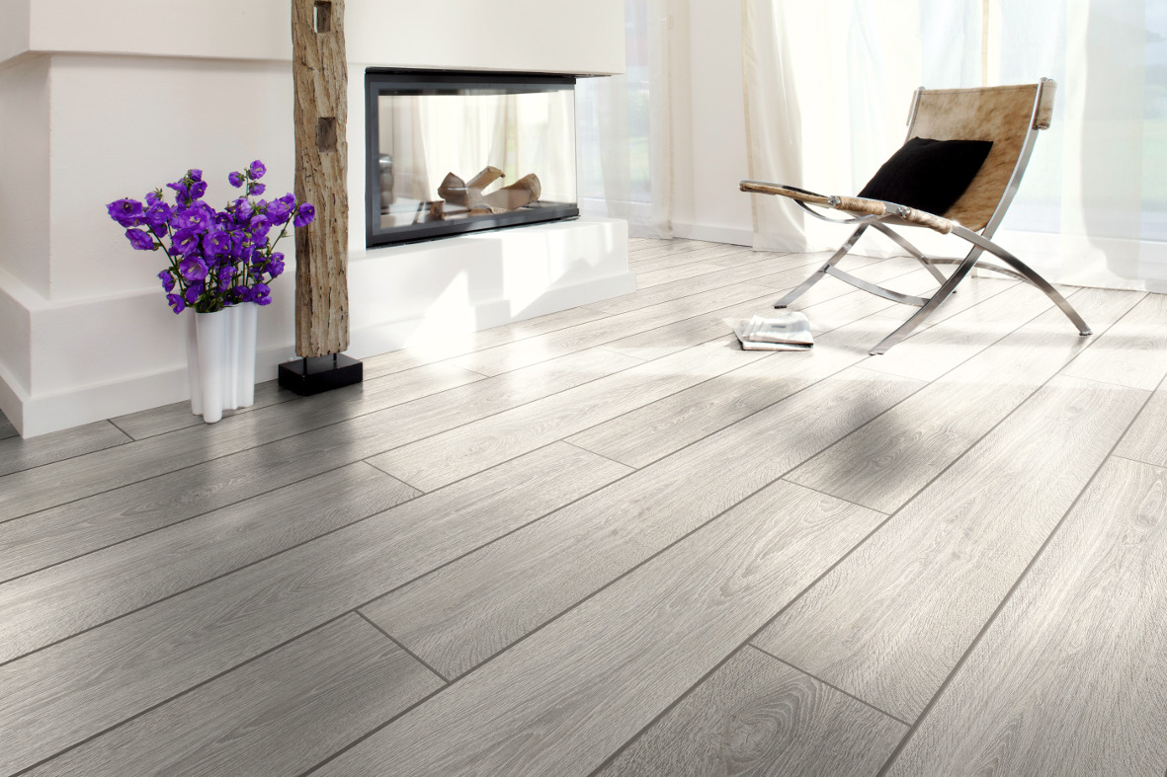 KRONOSTAR Synchro-Tec: Regular Oak (D 2800)

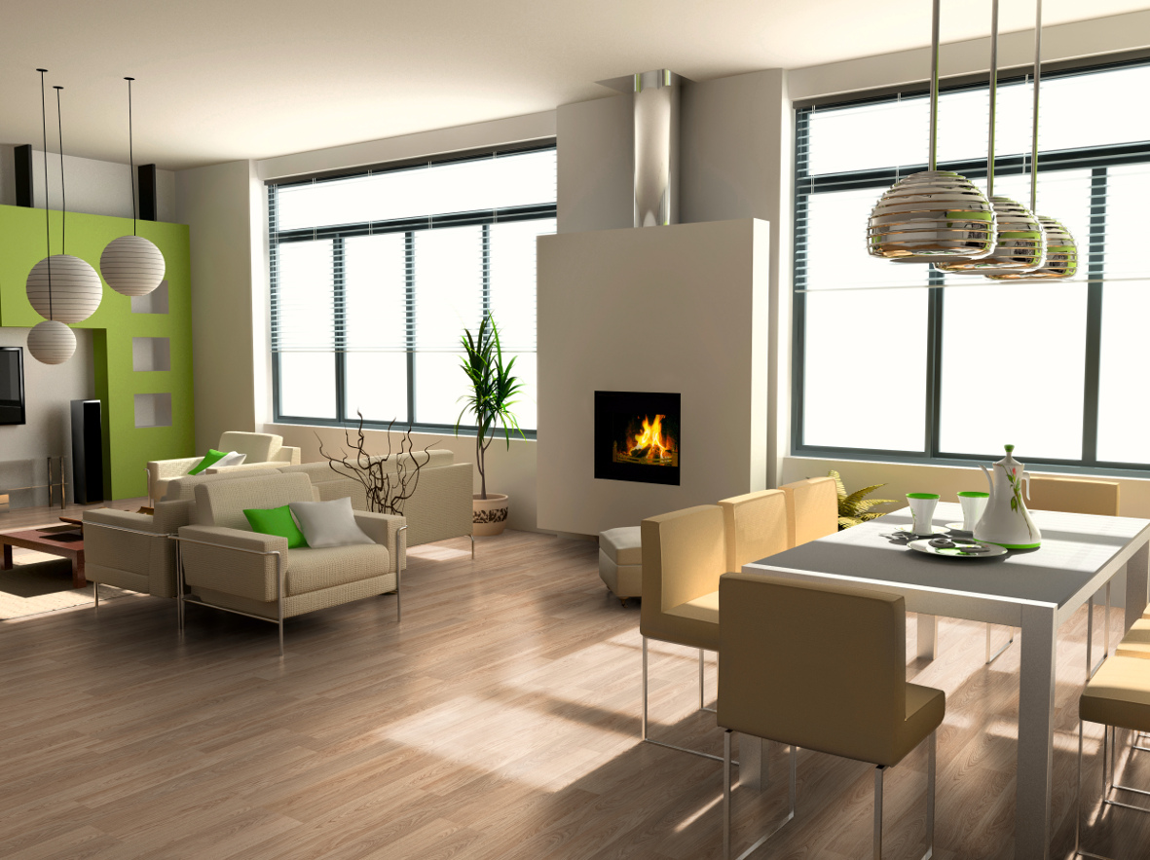 KRONOSTAR SymBio: Piemonte Oak (D 8149)

About the SWISS KRONO GROUP
The SWISS KRONO GROUP grew out of a firm which was established in Menznau, Switzerland in 1966. Today it is one of the world’s leading producers of engineered wood products with more than 4,500 employees. Its owners and staff are acutely aware of their multiple responsibilities – namely to succeed in business, deliver top quality and reduce environmental burdens – and are committed long-term to efficiently producing modern, eco-friendly products made from wood, a renewable raw material. KRONO Holding AG, which spearheads the Group, has its head office in Lucerne, Switzerland. www.krono.com

Press Contact  Ute Bachmann  Tel: +49 (0) 176 99938586  Fax: 03222 3350590  E-mail: u.bachmann@werbeagentur-nowack.de | KRONO Holding AG  Haldenstrasse 12  CH-6006 Lucerne  Switzerland  www.krono.com

About DOMOTEX
DOMOTEX, the world’s leading trade fair for floor coverings, will take place in Hanover, Germany from the 11th to 14th of January 2014. Around 1400 firms from 60 nations will display their new products and design highlights there. As the principal platform for the international flooring industry, DOMOTEX sends out important signals and anticipates future decorating trends. www.domotex.de

