KRONOPLY silverline: multifunctional and conducive to healthy living
The first eco-friendly wood-fibre insulation with aluminium lamination

June 2014 – KRONOPLY has once again extended its range of insulation products. The new KRONOPLY silverline is the first multifunctional, eco-friendly wood-fibre insulation for floors, walls and roofs. It actually performs six different functions:
- It reduces footfall-induced impact and reflected walking sound.
- It blocks electrosmog.
- It reflects infrared radiation to keep heat inside.
- It acts as a vapour barrier.
- It serves as an airtight layer.
- It provides additional thermal insulation.

This multifunctionality is made possible by the fact that one side is laminated with special aluminium foil (without using any additional adhesives). Amongst other things, the aluminium lamination blocks moisture (as a vapour barrier) and absorbs electromagnetic radiation.
“This product, with its properties and functions, is unique in the market at this time,” says Uwe Jöst, Managing Director of KRONOPLY. “Because it combines highly effective insulation, impermeability to vapour, airtightness and protection from electrosmog, this eco-friendly wood-fibre insulation ideally meets the needs of architects, planners, users and builder-owners.”

The Six Functions in Detail
1. Reduction of impact and reflected walking sound: KRONOPLY silverline’s most important function is reducing impact and reflected walking sound, which it does excellently. The big advantage of the aluminium lamination is that it eliminates the need to additionally install a PE membrane. KRONOPLY silverline can also be laid without problem on top of underfloor heating beneath laminate floor coverings up to nine millimetres thick.

2. Additional thermal insulation: KRONOPLY silverline also excels with its ability to supplement existing insulation. Particularly in the winter months, an extra five millimetres of insulation noticeably improve the indoor temperature while reducing heating bills.

3. Protection from electrosmog: KRONOPLY silverline is currently the only eco-friendly wood-fibre insulation that very effectively keeps electrosmog out. Measurements by the International Society for Electromagnetic Smog Research have shown that KRONOPLY silverline reduces electromagnetic radiation by more than 99.999%. It has been awarded the IGEF test mark for its pronounced shielding effect. Only 0.001% of the radiation striking the outside of the aluminium-laminated wood-fibre insulation was still detectable directly behind it.

4. Reflection of infrared radiation: KRONOPLY silverline provides thermal insulation by reflecting infrared radiation back into the room. Energy-efficient infrared radiation is emitted, for example, by radiative space heaters used to keep enclosed areas warm. KRONOPLY silverline reflects this infrared radiation to prevent heat loss.
5. Vapour barrier: The aluminium lamination also acts as a vapour barrier, making it unnecessary to lay any additional membranes. This ability makes KRONOPLY silverline particularly well-suited for use in roofs and walls.

6. Airtight layer: KRONOPLY silverline lends itself to creating a continuous airtight layer that keeps heat from escaping and condensation from penetrating. Adhesive aluminium tape is recommended for sealing the butt joints.

Easy to Use
Thanks to the product’s multifunctionality, there are only minimal storage costs. The packaging units are also easy to handle and transport.
Whether they are used as an alternative to barrier membranes in walls and roofs or to insulate against footfall noise, the lightweight yet sturdy panels are easy to cut to size using an appropriate knife or blade. It takes very little time to lay them, seal the joints between them and attach them to the substrate.

Images
The following images are available at the following link in a print-ready resolution and may be reproduced in periodicals free of charge provided that they are credited to “KRONOPLY”.
https://www.dropbox.com/sh/h8sq12qiowfjddw/AAC9FBF2BlrADqNCP-5F6O4Va

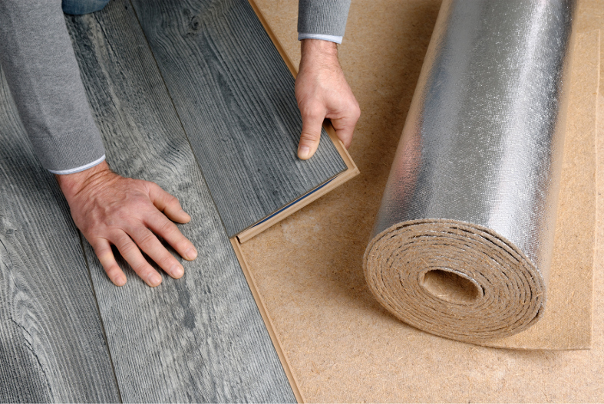

The aluminium-laminated KRONOPLY silverline is ideal for use under laminate flooring to reduce footfall sound.

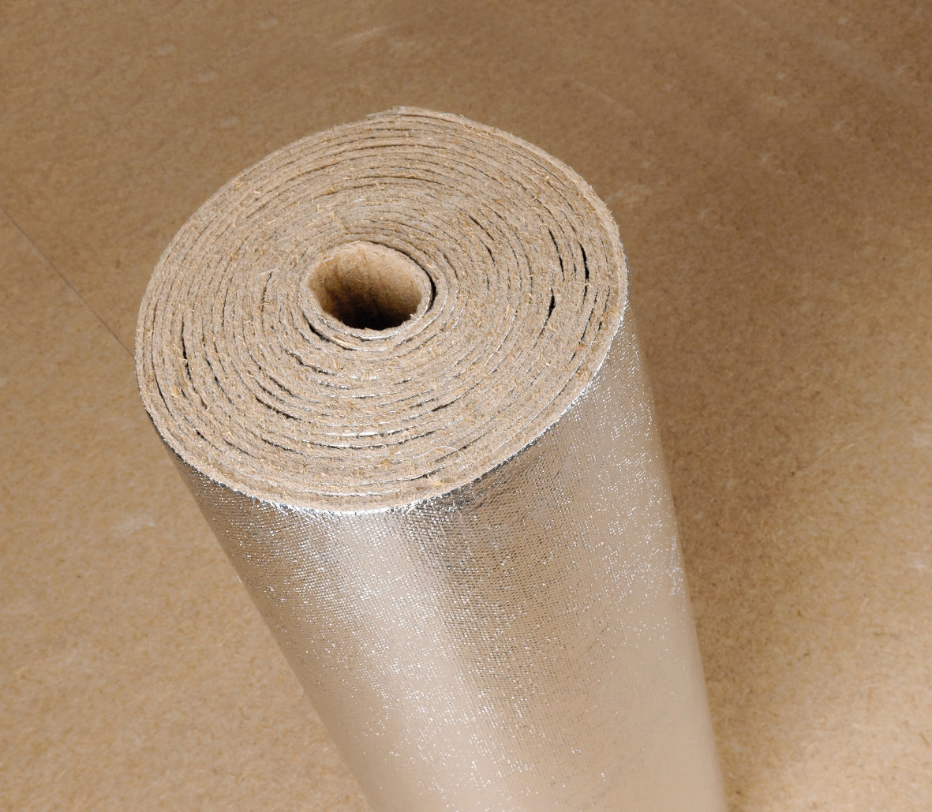

KRONOPLY silverline is the world’s first multifunctional wood-fibre insulation with aluminium lamination.

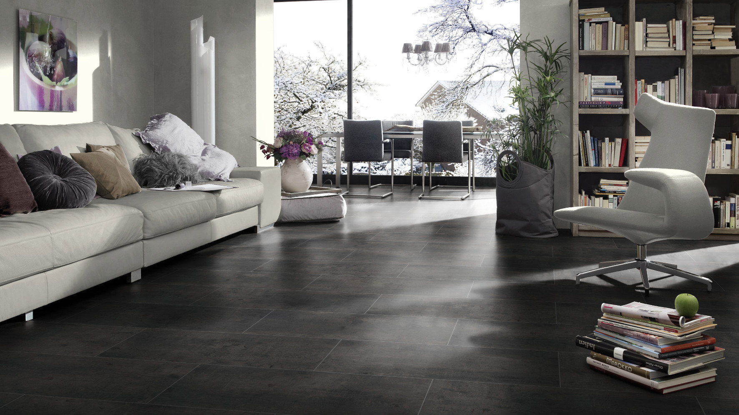

The wood-fibre insulation ensures a pleasant indoor climate and reduces heating costs.

About KRONOPLY GmbH
Established in 2000, Heiligengrabe, Germany-based KRONOPLY GmbH belongs to the SWISS KRONO GROUP, one of the world’s leading specialists in wood-based materials. KRONOPLY GmbH ranks among Europe’s most successful producers of OSB boards. Its core competencies also include producing MDF and HDF as well as high-quality wood-fibre insulation. The firm offers customer-focused solutions which involve innovative, environmentally friendly products and are backed by comprehensive consulting and support. In awareness of its responsibility to society, KRONOPLY GmbH makes flexibly deployable, custom-tailored wood-based materials from wood, a natural raw material. www.kronoply.com

Press Contact  Ute Bachmann  Tel.: +49 (0) 176 99938586  Fax: +49 (0) 3222 3350590  Email: u.bachmann@werbeagentur-nowack.de | KRONOPLY GmbH  Wittstocker Chaussee 1  16909 Heiligengrabe  Germany  www.kronoply.com

