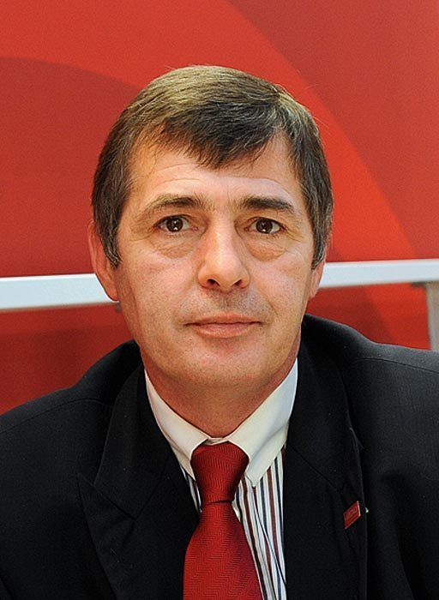
Questions and Answers on the Innovative Product KRONOPLY silverline

Answered by:
Uwe Jöst, Managing Director of KRONOPLY GmbH
and KRONOTEX GmbH & Co. KG

Events have been chasing one another at KRONOPLY this year. KRONOPLY silverline is the third innovative insulation product you have launched so far. Can you tell us something about it?
KRONOPLY silverline is five-millimetre-thick wood-fibre insulation laminated with special aluminium foil. It’s highly suitable for reducing footfall sound, and also features an integrated vapour barrier. KRONOPLY silver actually performs six different functions, which paves the way for a host of other applications.

Which functions are they?
KRONOPLY silverline attenuates footfall sound by up to 20 decibels, greatly reducing both impact and reflected walking noise. It can also be used as additional thermal insulation. In addition, KRONOPLY silver reflects infrared radiation, which prevents radiated heat from escaping. It’s also currently the only eco-friendly wood-fibre insulation which blocks so-called electrosmog. Measurements by the International Society for Electromagnetic Smog Research have shown that KRONOPLY silverline reduces electromagnetic radiation by more than 99%. The aluminium lamination simultaneously acts as a vapour barrier, eliminating the need to apply an additional membrane or similar product. And KRONOPLY silverline can be used to create a completely airtight layer that prevents heat from escaping and condensation from penetrating.

Who is the product likely to interest, and for what kinds of projects is KRONOPLY silverline especially well-suited?
KRONOPLY silverline is the ideal underlayment for laminate floor coverings. Beneath laminates up to nine millimetres thick, this wood-fibre insulation can also be laid on underfloor heating. KRONOPLY silverline is also excellently suited for installation in walls and roofs in place of a vapour barrier, both when constructing new buildings and in renovation projects. Owing to its multifunctionality, it meets several requirements at once.

To what extent do the benefits translate into time and cost savings?
The product’s multifunctionality significantly reduces storage costs. The rolls are also easy to handle and transport. As KRONOPLY silverline simultaneously acts as a vapour barrier, no additional membranes or foils are needed. This slashes costs for materials and speeds up work. As additional thermal insulation, KRONOPLY silverline also helps to cut down on heating costs. Our new product thus delivers practical benefits for merchants, installers and final consumers.

How did the idea for this product originate?
We were curious to see whether it was possible to laminate the insulation with aluminium foil before putting it through the press. The test results were positive, which prompted us to start thinking about the properties and uses of a product of this type.

How is KRONOPLY silver laminated and produced? Have you invested in any new systems?
First the special aluminium foil is laid on the wood-fibre mat. Then they pass through the press together. This approach eliminates the need to perform any additional steps or glue the lamination. We did invest in an appropriate new rolling system for KRONOPLY silverline.

Is the material completely recyclable?
After the end of its useful life, KRONOPLY silver can be incinerated to produce heat. The aluminium can also be reused without problem.

How does KRONOPLY silverline contribute to healthy living?
KRONOPLY silverline noticeably reduces footfall-induced noise (both impact and reflected walking sound). Less noise means less stress. In other words, the less noise we’re subjected to, the better we feel.
In addition, the amount of electromagnetic radiation (“electrosmog”) we’re exposed to has dramatically increased in recent years. The World Health Organisation has even designated high-frequency radiation as “possibly carcinogenic”. The aluminium lamination excellently blocks this radiation.
Plus, this natural insulation is also conducive to healthy living in other ways. Effective protection from heat, cold and moisture meets the prerequisites for a healthy indoor climate with a high feel-good factor.

How do you assess the sales potential? Has the market been waiting for this new product?
We believe that KRONOPLY silverline has very good market prospects, as it performs so many different functions. No other comparable multifunctional wood-fibre insulation is currently available.

Where and how will KRONOPLY silverline be available?
KRONOPLY silverline can already be ordered from all merchants who carry KRONOPLY and KRONOTEX products. To find a dealer near you, please get in touch with a KRONOPLY or KRONOTEX representative. You’ll find contact data on our websites.

About KRONOPLY GmbH
Established in 2000, Heiligengrabe, Germany-based KRONOPLY GmbH belongs to the SWISS KRONO GROUP, one of the world’s leading specialists in wood-based materials. KRONOPLY GmbH ranks among Europe’s most successful producers of OSB boards. Its core competencies also include producing MDF and HDF as well as high-quality wood-fibre insulation. The firm offers customer-focused solutions which involve innovative, environmentally friendly products and are backed by comprehensive consulting and support. In awareness of its responsibility to society, KRONOPLY GmbH makes flexibly deployable, custom-tailored wood-based materials from wood, a natural raw material. www.kronoply.com

Press Contact  Ute Bachmann  Tel.: +49 (0) 176 99938586  Fax: 03222 3350590  Email: u.bachmann@werbeagentur-nowack.de | KRONOPLY GmbH  Wittstocker Chaussee 1  16909 Heiligengrabe  Germany  www.kronoply.com

