Product Highlights from the SWISS KRONO GROUP at DOMOTEX 2016

January 2016 – The SWISS KRONO Group’s Swiss, German, Polish and Russian facilities will show off their innovativeness in creating laminate floors for healthy living at DOMOTEX 2016. All of the collections have been upgraded or supplemented, as a result of which SWISS KRONO will be showcasing a whole host of new products. The highlights:

KRONOSWISS of Switzerland:
GRAND SELECTION ORIGIN
The decors of these 14-mm-thick planks from Switzerland so closely resemble their inspiration – real solid rustic wood – that even experts have to look hard to tell the difference. There are two reasons for this. One is their fascinatingly precise in-register embossing. Second, the printed pattern repeats only about half as often as in other reproductions. These laminate floors are available in eight attractive colour versions, ranging from light to dark and from warm to cold; there’s something appropriate for every room and taste. GRAND SELECTION ORIGIN from SWISS KRONO is yet another high-quality Swiss product, following the trend that had already been set by GRAND SELECTION. All of the wood used to make these laminates comes from sustainably managed forests and more than 80 per cent of is of Swiss origin. Whenever possible, the products are FSC and PEFC certified. Thanks to a low-swelling HDF core, these exceptional floors are also more than twice as water-resistant as conventional laminates.
SWISS FLOORS
The SWISS FLOORS from Menznau, Switzerland has been optimised and expanded. A brand new addition is the SWISS LIBERTY line. Its four oak decors are sleek, elegant and moisture-resistant and ideal for creating a modern, urbane ambience in any room. The SWISS INFINITY line has gained five new ash colours. The existing SWISS MEGA line has also been upgraded. Boasting 690 x 398 mm tiles with new Stone Look surfaces, these extravagant decors are real eye-catchers. Additional benefits are delivered by a low-swelling, moisture-resistant HDF core and high AC5 Class 33-compliant abrasion resistance. The SWISS PRESTIGE line has been completely reworked and is now available in five modern colours with improved surfaces. And the SWISS SOLID line with six different decors is now once again part of the collection.

KRONOTEX of Germany:
2016 KRONOTEX FLOORING COLLECTION
The 2016 KRONOTEX FLOORING COLLECTION is premiering at this year’s DOMOTEX with 42 brand new decors from Germany. One of the many highlights is the new MAMMUT ^{plus} series with an extra-wide plank format of 1845 x 244 mm. Its nine oak decors with attractive colouring and in-register embossing are striking with their elegant, authentic natural wood looks, making them are ideal for evoking a comfortable country villa style.
New decors of several families of the 2016 collection also feature a newly developed Used Look surface. One particularly promising décor is Hella Oak (D4754), which is included in both the AMAZONE and the EXQUISIT series.
Two compelling new oak decors with newly developed embossed-in-register structures are included in several series: Gala Oak and Pettersson Oak. Both of them come in several colour versions.

KRONOPOL of Poland:
AURUM Flooring, PLATINIUM Flooring and (new) FERRUM Flooring
The SWISS KRONO GROUP’s Polish plant will also be on hand at DOMOTEX, where it will display not only its entire AURUM Flooring and PLATINIUM Flooring collections but also the brand new FERRUM Flooring collection, which comprises 30 decors in five different series.

WALL DESIGN
The Polish subsidiary will also unveil its new WALL DESIGN snap-together wall panel system. All of the coated MDF panel versions are ideal for both homes and commercial establishments. They come in various stone looks that open up a new dimension of interior decorating. There are no limits to their possible applications. Used on walls or ceilings, they evoke a pleasant, comfortable feeling. Their technical properties are also outstanding: they greatly improve thermal insulation and very effectively attenuate noise.

KRONOSTAR of Russia:
de facto
de facto is the first collection of embossed-in-register 12-mm-thick planks to come out of Russia. Six new decors with specially developed nature-identical surface structures now round off this top-of-the-market product range. de facto follows the successful debut of the Synchrotec collection with 8-mm-thick planks at DOMOTEX two years ago.

EcoTec
The entire entry-level EcoTec collection, which is produced in Russia, will also have its trade fair debut. All six of its decors – five oak looks and a cherry wood theme – are eco-friendly laminates for those who enjoy having flooring with a natural look & feel underfoot.

SymBio
SymBio is the Russian plant’s successful line of premium 8 mm AC5 floors with special matrix surfaces. This design collection has now been supplemented by two new oak decors, Trentino (D3478) and Toscana (D4644).

Images
The following images are available in print-ready for download and may be used in publications free of charge provided that they are credited to “SWISS KRONO”.

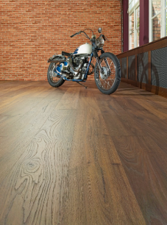 GRAND SELECTION ORIGIN, Sunset (D 4493)
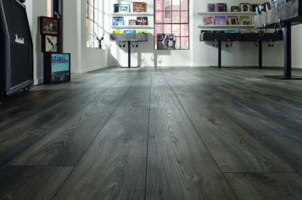 KRONOTEX MAMMUT ^{plus}, Macro Oak Grey (D 4792)
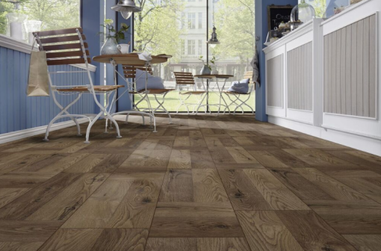 KRONOTEX EXQUISIT ^{plus}, Palace Oak Dark (D 4767)
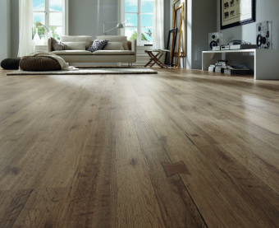 KRONOTEX DYNAMIC ^{plus}, Castle Oak (D 4755)
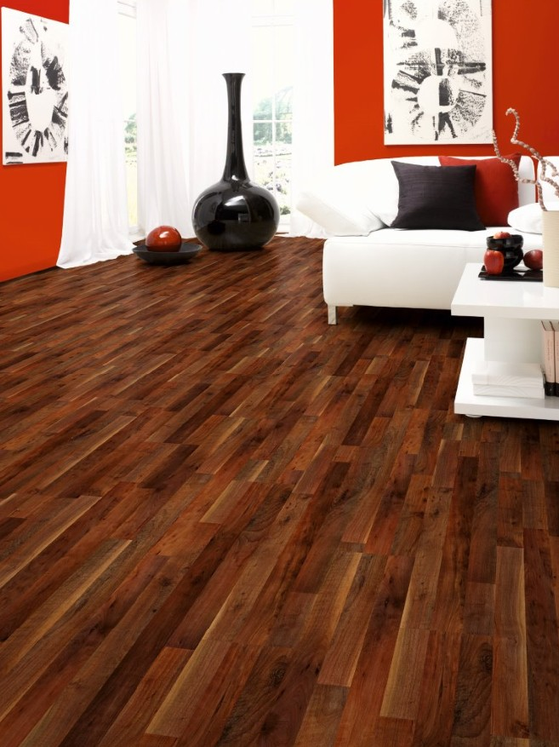 EcoTec, Cherry Sawyer (D 1505)
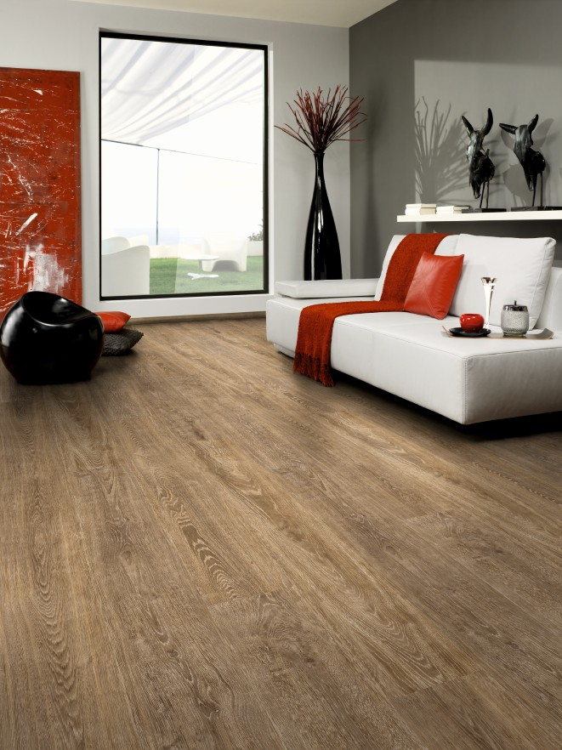 SymBio, Trentino Oak (D 3478)
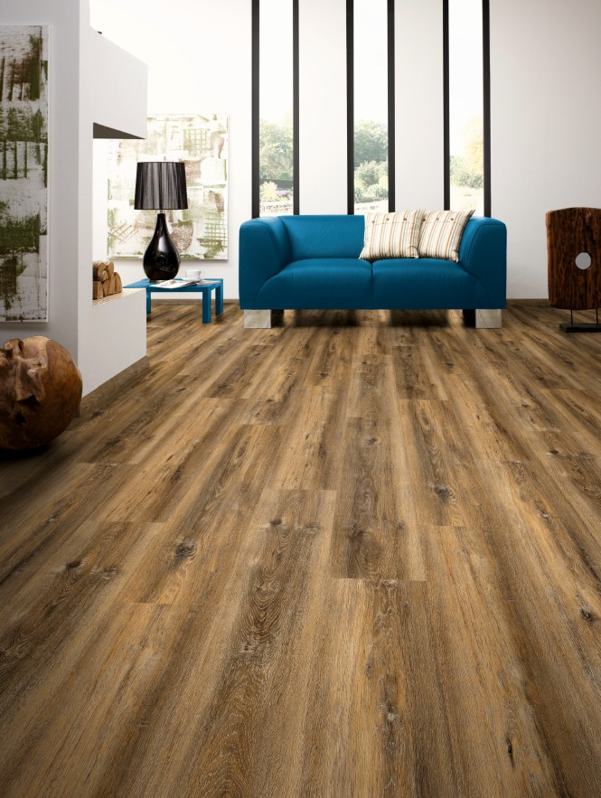 SymBio, Tuscan Oak (D 4644)
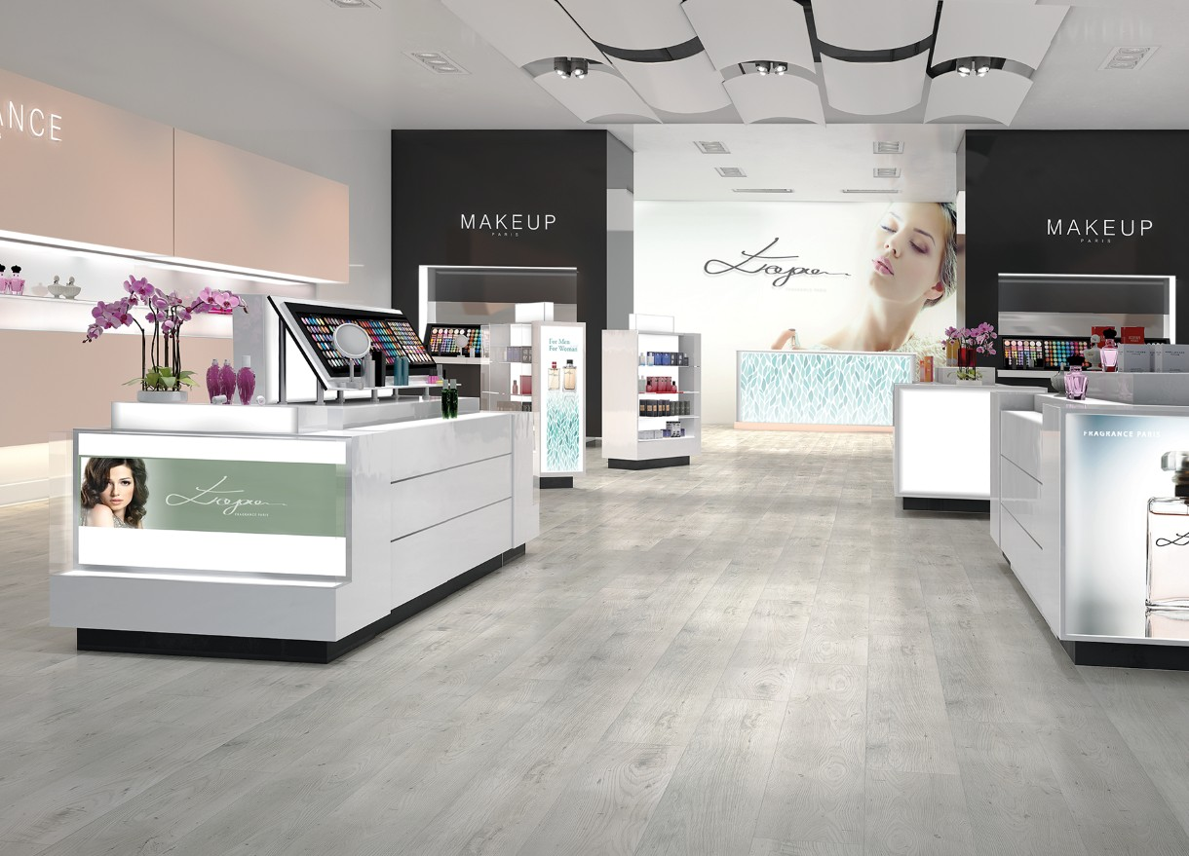 AURUM, Aroma, Jasmine Oak (D 3341)
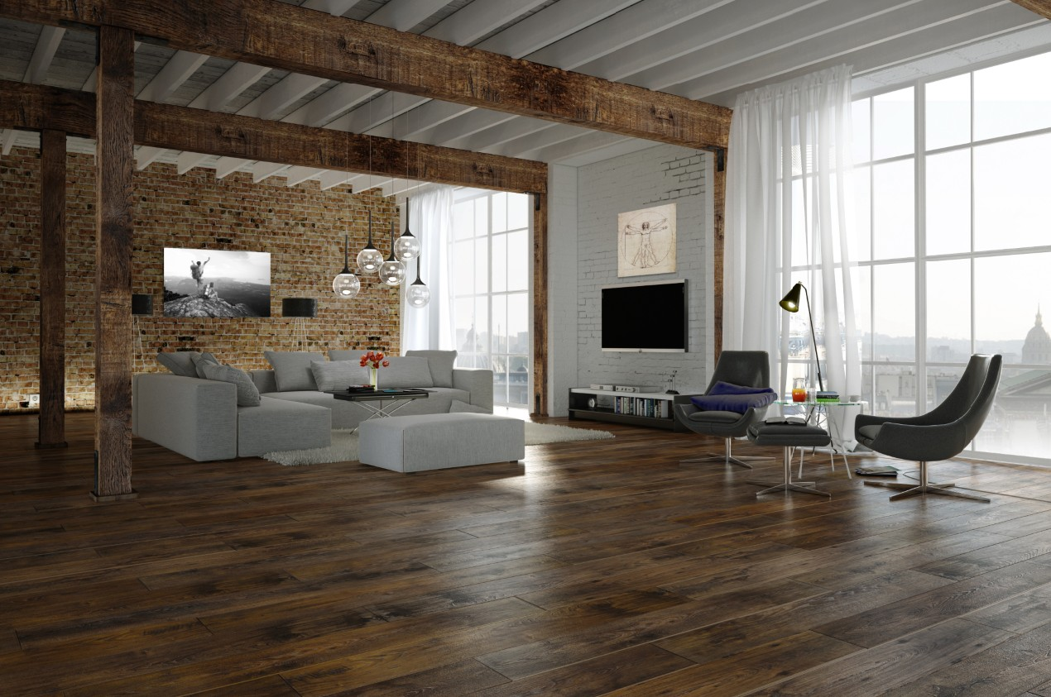 AURUM, Vision, Leonardo Oak (D 3347)
About the SWISS KRONO GROUP
The SWISS KRONO GROUP grew out of a firm which was established in Menznau, Switzerland in 1966. Today it is one of the world’s leading producers of engineered wood products with more than 4,500 employees. Its owners and staff are acutely aware of their triple responsibility – namely to succeed in business, deliver top quality and reduce environmental burdens – and are committed long-term to efficiently producing modern, eco-friendly products made from wood, a renewable raw material. The SWISS KRONO GROUP is headquartered in Lucerne, Switerzland. www.swisskrono.com

Press Contact  Urban Braun  Tel.: +41 (0) 41 419 03 20  Email: urban.braun@krono.com  Ute Bachmann  Tel.: +49 (0) 176 99938586  Fax: +49 (0) 3222 3350590  Email: u.bachmann@werbeagentur-nowack.de | SWISS KRONO GROUP  Haldenstrasse 12  CH-6006 Lucerne  Switzerland  www.swisskrono.com

