Market Launch of the First Villeroy & Boch Flooring Line

Villeroy & Boch, which offers a complete range of products for kitchens, bathrooms and tabletops, is now extending its home portfolio to include high-quality flooring. It has cooperated with the Swiss Krono Group to create the first Villeroy & Boch Flooring Line, which will be unveiled for the first time to a trade audience at the Domotex flooring fair in Hanover in January 2014. The Villeroy & Boch Flooring Line will be available worldwide from the 1st quarter of 2014.

The Villeroy & Boch Flooring Line

The first Villeroy & Boch Flooring Line comprises a total of 22 newly developed decors grouped into four collections: Cosmopolitan, Country, Contemporary and Heritage. All four collections include both natural-looking decors and urbane designs. This first Villeroy & Boch Flooring Line addresses a target group consisting mainly of style- and brand-conscious consumers who value a personalised touch and high standards of quality. All of the products fall into the premium segment.
Sales territories have been defined for the overall flooring line. The available decors of the Cosmopolitan collection will vary in the territories depending on regional requirements.

Cooperation with the Swiss Krono Group

The internationally active Swiss Krono Group possesses proven expertise in designing and producing innovative laminate floors that unite the attributes of aesthetics, functionality and environmental friendliness. The Swiss Krono Group shares Villeroy & Boch’s highly professional approach, international market position and goal of designing attractive products to enhance home living culture, thus making the two firms ideal partners. Their alliance is being set up for the long term and is the first of its kind for both enterprises.

Picture:
The following picture may be reproduced in periodicals free of charge provided that it is credited to Villeroy & Boch.

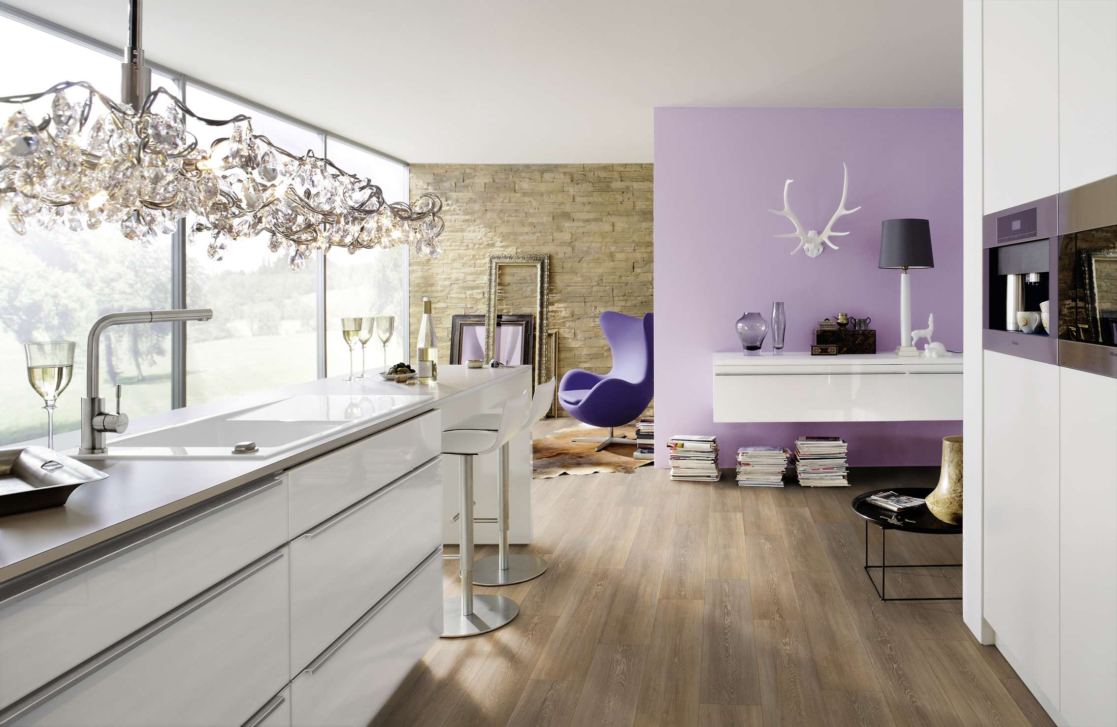
Title theme of the first Villeroy & Boch Flooring Line

Press contact:
Ute Bachmann
Tel.: +49 (0)176 99938586
E-mail: u.bachmann@werbeagentur-nowack.de

Villeroy & Boch
Villeroy & Boch is based in Mettlach, Germany and has production facilities in Europe, Mexico and Thailand. It is already represented in 125 countries with bathroom, wellness and tabletop products as well as tiles. The stock exchange listed firm has a history going back 265 years.

