SWISS KRONO GROUP: New management to implement a sustainable growth strategy under a new umbrella brand

Lucerne, 30 June 2016 – The SWISS KRONO GROUP ranks among the world’s leading manufacturers of engineered wood products. With ten factories in eight countries, products for timber construction as well as for decorative furniture and interior fittings are manufactured. In the area of laminate flooring, the SWISS KRONO GROUP is the global market leader. Services tailored to customer requirements and regional differences complete the package of offered products. At the beginning of 2016, the names and logos of the individual sites are being replaced by a single, unified brand image. Since then, the corporation is acting as an integrated group under the name of SWISS KRONO.

The group will also prepare itself to use organic and external growth to actively take advantage of the development opportunities for modern engineered wood products that will come its way in the next few years. The broad customer base, a leading technological role as well as a strong capital and financial base provide the ideal preconditions for this. At this time, significant investment and expansion projects are also being implemented at four locations (Hungary, Russia, Switzerland and the USA).

In order to implement this strategy consistently, the corporation will have new strategic and operative management. Beginning on the 1st of October 2016, Martin Brettenthaler will take over as the new CEO of the SWISS KRONO GROUP replacing Maciej Karnicki. Mr Brettenthaler (45) has dual Austrian and Swiss citizenship, is at home in Basel, married and father of two children. He was educated in economics in St. Gallen and Paris and worked for a few years as a management consultant at the Boston Consulting Group before entering the timber industry fifteen years ago.

Maciej Karnicki, who, in his dual role as the CEO of the SWISS KRONO GROUP and as the Site Manager of the corporation’s largest factory in Poland, has efficiently pursued a successful course for the SWISS KRONO GROUP until now, will, at his own request, in future be responsible and develop business activities of the Polish production facility.
The President of the Board of Directors, Ines Kaindl, feels confident saying, “I am happy that we were able to win Martin Brettenthaler for our group. Together with the experienced and long-standing executive management board and our site management, he will implement our ambitious strategy with success in the years to come.”

Image Rights
The picture of Martin Brettenthaler is available for download and may be used within the editorial environment with the picture credit “SWISS KRONO GROUP”.

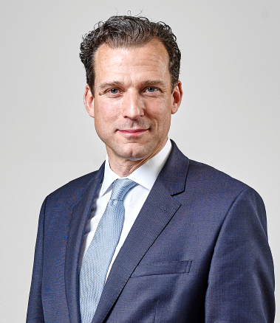 Martin Brettenthaler

About SWISS KRONO GROUP
Having emerged from the company Kronospan, founded in 1966 by entrepreneur Ernst Kaindl in Menznau, Switzerland, today, with more than 4,500 employees, the SWISS KRONO GROUP is one of the leading global engineered wood producers companies. In the 2014/15 fiscal year, the corporation achieved a turnover of
CHF 1.8 billion. For the owner and employees, efficiency, uncompromised focus on quality and environmental orientation are at the centre of their business activities. The SWISS KRONO GROUP produces modern, environmentally compatible products made of wood, a naturally renewable resource, using long-term oriented and efficient methods. The headquarters of the SWISS KRONO GROUP are located in Lucerne, Switzerland.

For further information, please contact:
Press contact  Cornelia Schreyer  Tel: +41 44 206 60 12  Email: cornelia.schreyer@swisskrono.com | SWISS KRONO GROUP  Haldenstrasse 12  6006 Luzern, Switzerland  www.swisskrono.com

