THE NEW ONE
The SWISS KRONO GROUP Is Heading for the Future

January 2016 – The SWISS KRONO GROUP is poised to introduce a single unified brand image for all of its companies in 2016. According to Ines Kaindl, President of the Administrative Council of the SWISS KRONO GROUP, “We want to leverage a strong, uniform brand to spotlight our tradition and history while making a greater international impact. This will enable us to help shape the market’s future.” The Group’s member firms in Germany, Poland, Russia and Switzerland will unveil the new corporate design at a shared stand at DOMOTEX 2016.

THE NEW ONE – the New Brand Image of the SWISS KRONO GROUP
This corporate group ranks among the world’s leading manufacturers of engineered wood products. Eleven plants in eight countries make timber construction, flooring and decorative products and provide customer-focused services which optimally meet the requirements of each region and its customers.
Until recently, each site operated with its own company name and image. Now, however, the Group is closing ranks, pooling its expertise and forging a common identity. In 2016 the names and logos of the individual sites are being replaced by a single, unified brand image. From this point on, all of the Group’s plants will bear the SWISS KRONO name. This, together with a new logo and the slogan “Wood at its best” (translated into each local language), will enable all of the firms to clearly signal their membership of the SWISS KRONO GROUP. “This consistent image and our modern, visually striking new logo are giving the Group a single face with a clear profile,” says Max von Tippelskirch, CMO of the SWISS KRONO GROUP. “They will let us clearly differentiate ourselves from our competitors and strengthen our presence in the global marketplace. As a result, we will remain competitive while continuing to meet international needs in today’s globalised world.”
Logo: | Icon:
The New Company Brands
During the course of 2016, the firms will be renamed as follows:

Old name (country) New name (country code - location)
Kronospan Schweiz AG (Switzerland) SWISS KRONO AG (CH – Menznau)
Kronofrance SAS (France) SWISS KRONO SAS (FR – Sully-sur-Loire)
Kronotex GmbH & Co. KG SWISS KRONO TEX GmbH & Co. KG
Kronoply GmbH (Germany) SWISS KRONO GmbH (DE – Heiligengrabe)
Kronopol Sp.z.o.o. (Poland) SWISS KRONO Sp.z o.o. (PL – Żary)
000 KronoStar (Russia) 000 SWISS KRONO (RU – Sharya)
KronoUkraine LLC (Ukraine) SWISS KRONO TOB (UA – Kamianka-Buska)
Kronotex USA Holdings, Inc. (USA) SWISS KRONO LLC (USA – Barnwell)
Interspan Faipari Kft. (Hungary) SWISS KRONO Kft. (HU – Vásárosnamény)

“By unifying our brand image, we are going to signal to our customers that we belong together and are able to offer integrated, holistic solutions,” says Ines Kaindl, President of the Administrative Council of the SWISS KRONO GROUP. “Our sites will continue to have a certain degree of independence, as we definitively want to preserve the different cultures in their countries. But we will now be presenting ourselves as one enterprise.”
Letting the sites grow together in this way will drive more intensive joint R & D activities with the goals of becoming more capable and dynamic and getting even better at flexibly implementing solutions to serve individual customers. “Our sites will benefit from new synergies and inspire one another to develop further as a team,” says Maciej Karnicke, CEO of the SWISS KRONO GROUP. “The name of the game is ‘think globally but act locally’. Our new, coordinated brand presence will also help us offer our business partners greater security by ensuring that the same high standards apply to every SWISS KRONO plant.”

Reorganisation and Consolidation of the Product Brands
Innovative, high-quality products will continue to be the pillars of the SWISS KRONO GROUP. Looking ahead, the portfolio will be divided into three segments:
SWISS KRONO Interiors – products for furniture and interior finishing
SWISS KRONO Building Materials – products for timber construction
SWISS KRONO Flooring – products for floor coverings

Step-by-Step Consolidation
The Group will implement this reorganisation within three to five years by following a schedule that has been agreed on with all of the responsible managers.
The new look will debut in public at DOMOTEX 2016. Instead of the red stand design used in the past, the new SWISS KRONO GROUP exhibit will sport modern white-red livery.
In addition, replacing the corporate website at www.krono.com, the SWISS KRONO GROUP can now be found on the internet at www.swisskrono.com. The new website is organised into sections corresponding to the product segments. Hyperlinks let users jump to the existing websites of the member firms, which will be gradually brought up to speed and harmonised.

An International Brand for the Future
This year the SWISS KRONO GROUP is celebrating the 50th anniversary of its 1966 founding by Ernst Kaindl in Menznau, Switzerland, which marked the start of its trajectory towards becoming the globally operating corporate group which it is today. The Group wants to take advantage of this jubilee to send a clear signal and redefine itself as a strong new brand with international reach for the future. “We are convinced that we are on the right track for preparing our enterprise to face the challenges of the next 50 years and become even more competitive,” says Ines Kaindl.

Images
The following images are available in print-ready for download and may be used in publications free of charge provided that they are credited to “SWISS KRONO”.

New SWISS KRONO logo
New SWISS KRONO icon

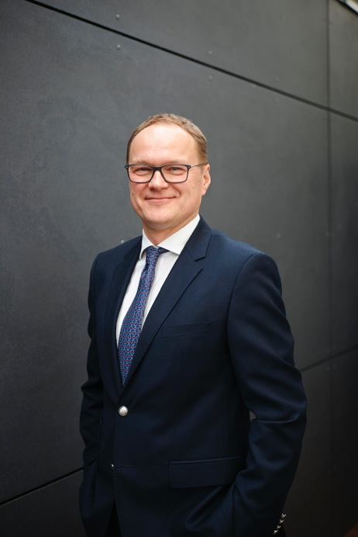 Maciej Karnicki, CEO of the SWISS KRONO GROUP
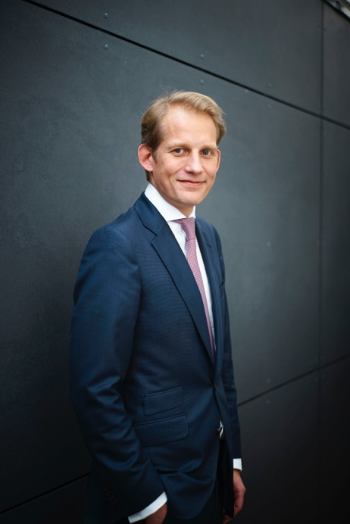 Max von Tippelskirch, CMO and Member of the Management Board of the SWISS KRONO GROUP

About the SWISS KRONO GROUP
The SWISS KRONO GROUP grew out of a firm which was established in Menznau, Switzerland in 1966. Today it is one of the world’s leading producers of engineered wood products with more than 4,500 employees. Its owners and staff are acutely aware of their triple responsibility – namely to succeed in business, deliver top quality and reduce environmental burdens – and are committed long-term to efficiently producing modern, eco-friendly products made from wood, a renewable raw material. The SWISS KRONO GROUP is headquartered in Lucerne, Switerzland. www.swisskrono.com

Press Contact  Urban Braun  Tel.: +41 (0) 41 419 03 20  Email: urban.braun@krono.com  Ute Bachmann  Tel.: +49 (0) 176 99938586  Fax: +49 (0) 3222 3350590  Email: u.bachmann@werbeagentur-nowack.de | SWISS KRONO GROUP  Haldenstrasse 12  CH-6006 Lucerne  Switzerland  www.swisskrono.com

